Table of Contents

1. Introduction 2

2. Getting Started 2

2.1 System Requirements 2

2.2 Installation 2

3. User Registration 2

4. User Login 3

5. Role Selection 3

6. User Roles and Dashboards 3

6.1 Public User 3

6.2 Restaurant Owner 3

6.3 Data Analyst 3

7. Features by Role 3

7.1 Public User Dashboard 3

7.2 Restaurant Owner Dashboard 3

7.3 Data Analyst Dashboard 4

USER MANUAL

1. Introduction

Welcome to the NYC Restaurant Surveillance System! This software allows users to access restaurant data, perform data analysis, and view visualizations based on their roles. Whether you're a Public User, Restaurant Owner, or Data Analyst, this guide will help you get started.

1. Getting Started
   1. System Requirements

* Operating System: Windows
* Python 3.7 or higher
* Required Python packages (will be installed during setup)
* Internet connection (for data retrieval)

## Installation

* Download the Software: Download the software package from the provided source.
* Install Dependencies: If required, install Python and any additional dependencies mentioned in the installation guide.
* Run the Application: Execute the application by running the main script (task.py).
* Install the necessary Python libraries and modules using a package manager like pip
* tkinter: For the GUI components.
* pandas: For data manipulation and analysis.
* matplotlib and seaborn: For data visualization.
* numpy: For numerical operations.
* sqlite3: For SQLite database access.

# User Registration

* Click on the "Register" button on the login screen.
* Provide a unique username, password, and select your role (Public User, Restaurant Owner, or Data Analyst).
* Click "Register."

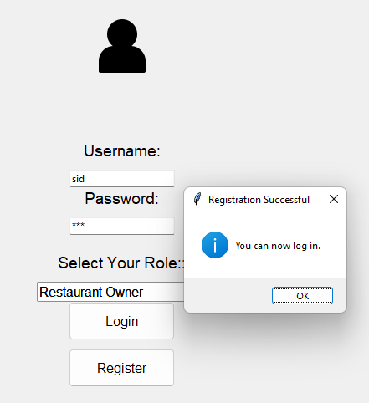

# User Login

* Enter your username and password on the login screen.
* Click "Login."

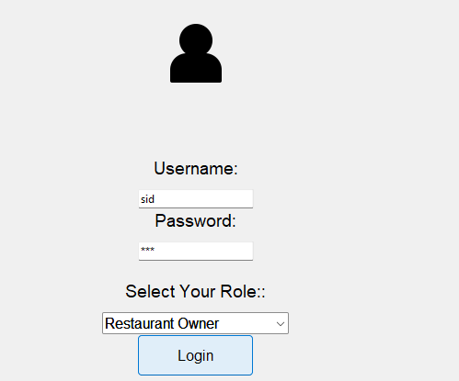

1. Dashboard Selection

* After successful login, you will be prompted to select your role.
* Choose from “Inspection Details", "Explore Violation", "Report”

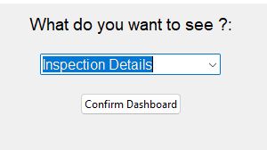

1. User Roles and Dashboards
   1. Public User

* As a Public User, you can access restaurant inspection data visualizations.
* The dashboard will display a bar chart showing inspection counts by borough and statistical information about restaurant inspections.
  1. Restaurant Owner
* Restaurant Owners can use the system to search for specific restaurants.
* The dashboard includes a search feature and displays a list of restaurants with details such as name, location, and inspection score.
  1. Data Analyst
* Data Analysts have access to data analysis tools.
* The dashboard provides options to select and analyze datasets, visualize data, and view statistical information.

# Dashboards

* 1. Inspection Details Dashboard
* Data Visualization: Explore visualizations of restaurant inspection data.
* Statistics: View statistics related to restaurant inspections.
  1. Explore Violation Dashboard
* Restaurant Search: Search for restaurants based on criteria.
* Restaurant Data: View details of restaurants, including names, locations, and inspection scores. and their violations
  1. Report Dashboard
* Data Analysis: Select datasets and analyze data.
* Data Visualization: Create visualizations (charts) based on the selected data.
* Statistics: Access statistical information related to the data.
* Report anything wrong to the system

